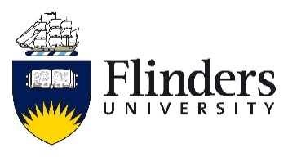
College of Humanities, Arts and Social Sciences

Instructions
Complete all sections to this form and return to the Student Representation and Development Officer srdo@flinders.edu.au. Your answers don’t have to be long but should contain enough detail that others can see you have some awareness of what it is like being a student at Flinders.

The Basics
Name: ___________________________ Student No. __________________________
Phone: ___________________________ Email: _______________________________
Degree: _____________________________________________________________________
Please indicate which course you are applying to represent:
Arts Archaeology Media Arts Media and Communication Languages Tourism and Events Creative Arts
Please indicate which year level you are applying to represent:
First Second Third Honours Postgraduate
Will you be a student at Flinders in Semester 2 2020? Y or N

Why would you like to be a student representative for your year level?

Describe those attributes and experiences which you feel equip you to be a student representative for your year level in your Course:

The Student Experience in your Course
Describe both where you think your College/Course/Year is doing well and those areas in which it might improve with respect to the academic experiences of students. Key areas to consider here include: teaching and assessment methods, program and course organisation, and program structure and quality. First year students may answer this question in relation to what they think a good learning experience looks like in first year.

Staff Referee
Please provide a name and email for one Flinders staff member (this can be an administrator or academic) who can speak in support of your application.
NAME: ________________________________ EMAIL: ___________________________
Have you asked this person to act as a referee for you (recommended)? Yes/No

Once completed please email this form and a current CV to the Student Representation and Development Officer srdo@flinders.edu.au.

